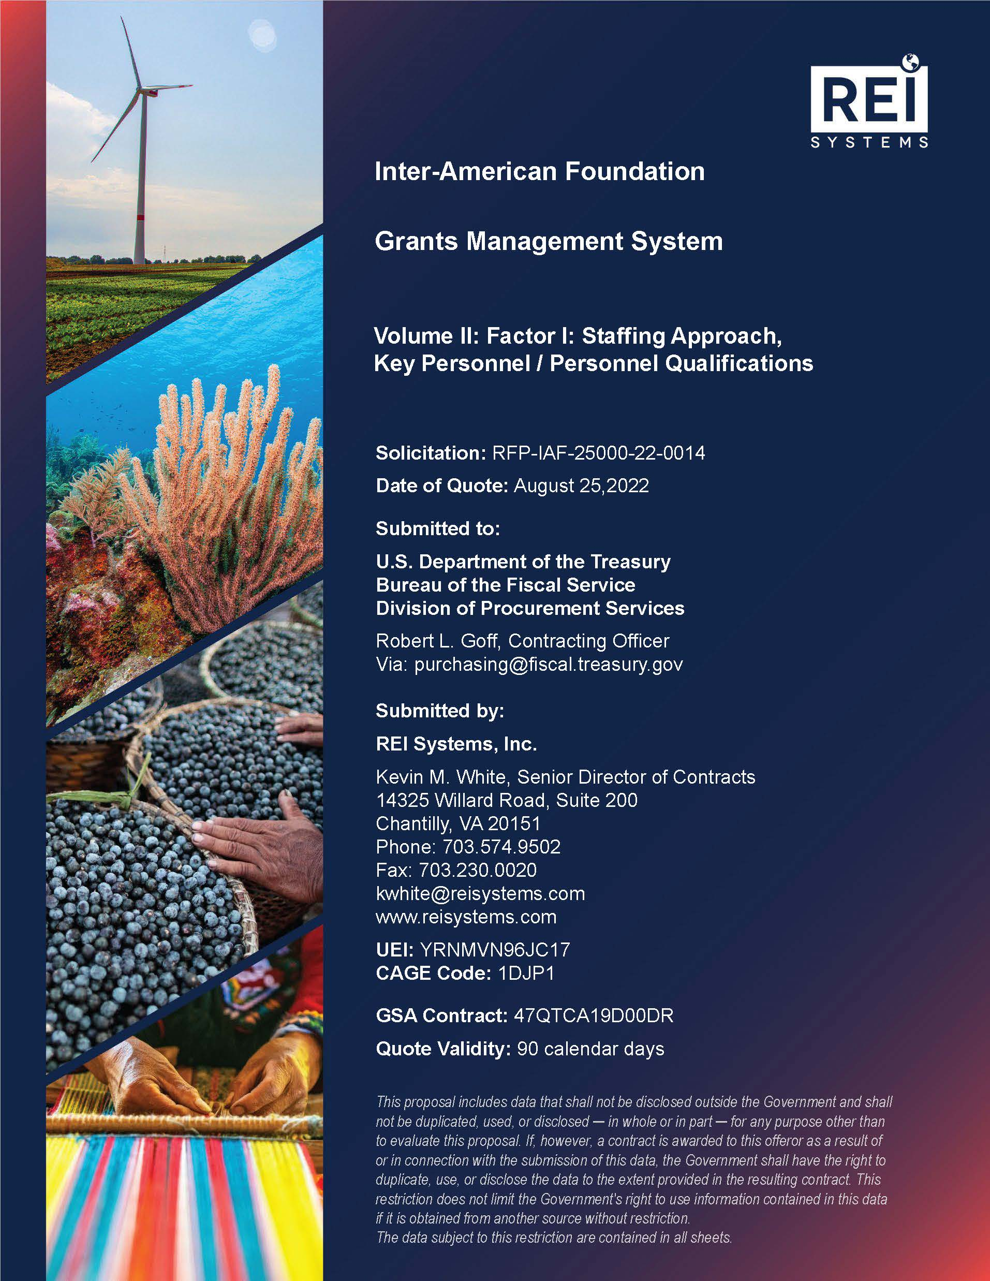

Table of Contents

Volume II: Factor I: Staffing Approach, Key Personnel / Personnel Qualifications 1

1 TEAM REI Overview 1

2 Education and Experience 2

2.1 Project Manager 2

2.2 Technical Manager 4

2.3 Business Analyst 4

3 Staffing Plan 5

4 Corporate Commitment and Reach-Back Capability 7

5 Staffing Approach 8

APPENDIX A Key Personnel Resumes 1

A1 Project Manager 1

A2 Technical Manager 4

A3 Business Analyst 7

TABLE of Figures

Figure 1: Proposed REI Key Staffing Roles for the IAF’s Grants Management System Project 2

Figure 2: REI Systems’ Corporate Organization 7

Figure 3: GovGrants Organization’s Three Teams: Product, Implementation/Delivery, and Customer Success ………………………………………………………………………………………………………………7

tABLE of Tables

Table 1: Project Manager Grants Implementation Experience 3

Table 2: Technical Manager Grants Implementation Experience 4

Table 3: Business Analyst Grants Implementation Experience 5

Table 4: Team REI Staffing Roles and Responsibilities 5

Volume II: Factor I: Staffing Approach, Key Personnel / Personnel Qualifications

# TEAM REI Overview

REI Systems, Inc. is an employee-owned company that has been supporting federal and state agencies for more than 33 years. We are unique in our industry. While many of our competitors have grown through mergers and acquisitions — purchasing customers and capabilities — our growth has been purely through solid, proven delivery and building trusted customer relationships that span decades.

REI has been designing, developing, deploying, operating, maintaining, and enhancing grants management systems for public sector customers for more than 20 years. **Today, more than 300 of REI’s employees support Grants Management Systems (GMS) across the government.** Our portfolio of customers includes the National Aeronautics and Space Administration (NASA), Health Resources and Services Administration (HRSA), the Department of Health and Human Services (HHS), the Department of Homeland Security (DHS), the General Services Agency (GSA), and the Food and Drug Administration (FDA), as well as state/local agencies in California, Texas, Utah, Louisiana, Washington, South Carolina, Los Angeles, San Diego, Washington DC, and more.

REI has a deep Grants Management Resource Pool.

Nearly 300 of our staff support grants management systems across federal, state, and local government customers today.

We offer the IAF a deep pool of resources and SMEs from which to draw.

REI has teamed with **Stealth Solutions, Inc.** (Stealth) to form Team REI to implement GovGrants for the Inter-American Foundation (IAF). Stealth is an 8a-certified small business with technical and functional expertise in grants management. Stealth has been working with REI for more than eight years on multiple GovGrants implementations, including at the United States Agency for International Development (USAID), the DC Department of Health (DC DOH), the Louisiana Community and Technical College System (LCTCS), the City of San Diego, the Region of Peel (Canada), the Los Angeles Homeless Services Authority (LAHSA), the Legal Services Corporation (LSC), and the National Endowment for Democracy (NED).

Team REI’s deep bench of resources provides IAF with a pool of grants management Subject Matter Experts (SME) and staff to rely on over the course of project execution.

Team REI is the Ideal Partner to Achieve the IAF Objectives

Achieving IAF objectives means finding and keeping the right resources to ensure the highest productivity and collaboration throughout the contract. Our staffing approach is to create a project team for IAF that minimizes execution risk and provides high-quality staff with knowledge and skills for implementing GovGrants across multiple customers.

Team REI’s proposed project staff brings more than 30 years of combined experience in grants, technical, and management domains and is ready to start on Day 1. As with each of our projects, this project staff has extensive corporate reach-back support and resource availability. We know how to bring the right mix of skills to meet the IAF objectives through this Staffing Approach.

Our proposed staff are based out of REI’s Sterling, Virginia location. However, given the physical proximity to IAF’s offices, they can travel to the IAF office for meetings and reviews, as needed or required. We believe that many of the initial Gap Analysis sessions will be best facilitated in person, if possible, to allow for maximum collaboration and engagement.

Team REI will staff a diverse, experience-rich team to support IAF. Each of the proposed staff has experience on multiple grants management implementations similar to the IAF GMS using the GovGrants COTS product.

The IAF leadership will oversee that the project is meeting the strategic objectives established for the GMS. Leadership will review progress reports, which include risks, issues, and progress. All decisions related to the contract and significant schedules will be communicated and concurred upon by this group. Project execution will be managed by the Team REI Project Manager (PM) in coordination with the IAF Project Manager.

**Figure 1** below shows the organization structure and the reporting relationships within the project. The established reporting relationship provides a governance structure for the project.

Figure 1: Proposed REI Key Staffing Roles for the IAF’s Grants Management System Project

Team REI provides resumes for our key personnel in **Appendix A**.

# Education and Experience

Team REI’s key personnel to support IAF in this project are a PM, a Technical Manager (TM), and a Business Analyst (BA). The following section provides education and experience qualifications for each role. As noted above, all three key personnel are local to the Washington, DC area for ad hoc meetings and problem-solving sessions.

## Project Manager

Team REI’s proposed PM has more than 17 years of experience in Information Technology (IT) software application development and contributing to different stages of a project’s lifecycle, including business and system analysis, requirements gathering, system design, system testing, system maintenance, documentation, and end-user support, and project delivery and management. Most of his experience (15+ years) is in working on grant management systems for several federal and state customers such as HRSA, the Federal Emergency Management Agency (FEMA), NASA, Washington DC National Fish & Wildlife Foundation (NFWF), and the Washington Office of Superintendent of Public Instruction (OSPI). In the last five years, he has managed GovGrants implementations with state, local, and non-profit customers. Over the last 11 years, he has developed core competencies in the areas of business analysis, hands-on requirements gathering, requirements management, solution concept development, project delivery, and management. He is an experienced PM and Product Owner who has managed multiple parallel projects with an average team size of up to 15 members (avg. annual budget of $2 million) with a mix of Agile and Iterative Software Development Lifecycle (SDLC) methodologies.

Project Manager Education

* M.S., Mechanical Engineering, University of Cincinnati, Cincinnati, Ohio
* B.E., Mechanical Engineering, Dayanand Sagar College of Engineering (Bangalore University), Bangalore, Karnataka, India

Project Manager Certifications

* MI PMP, December 2013
* Introduction to Grants & Cooperative Agreements - Certification (Management Concepts), January 2020
* Monitoring Grants and Cooperative Agreements – Certification (Management Concepts), February 2020
* SOAR Leadership Training from Chalmers Brothers, 2015
* SEI, Introduction to CMMI, Staged Representation, v1.1, 2005
* SEI, CMMI v1.2 Upgrade Training
* ISO 9001:2000 CMMI Level 3
* 15+ years of grant experience with 5+ years supporting GovGrants implementations

Table 1: Project Manager Grants Implementation Experience

| **Agency/Office** | **Role** | **Implementation Team Size** | **Key Statistics** |
| --- | --- | --- | --- |
| South Carolina Department of Education (SCDE) | Project Manager | 10+ | * April 2022 rollout included support for eight federal entitlement formula grants. * Plans to roll out additional formula grants and federal/state competitive grants in 2023. * Supporting 150 internal and 1,600 external licenses. |
| Washington Office of Superintendent of Public Instruction | Project Manager | 10+ | * Phase 1 rollout includes support for eight federal entitlement formula grants, federal formula consortium grants, and a few state and competitive federal grants. * Supporting 65 internal users and 2,000 external users in Phase 1. |
| Washington DC National Fish and Wildlife Foundation | Project Manager | 8+ | * Managing 1,000+ awards received by NFWF. * 130 internal users in Phase I. |
| Health Resources and Services Administration  Enterprise Level E-Grants Platform | Senior Manager / Product Owner | 20 | * 10,637 applications/year. * 27,000 grants awarded/year. * $7.5B awarded/year. * 46,000 users. |
| Federal Emergency Management Agency Emergency Management Mission Integrated Environment (EMMIE) | Quality Assurance Lead / Quality Assurance Analyst | 15 | * 24+ disaster-focused grants programs. * 22,540 applications/year. * 5,275 grants awarded/year. * $753M awarded/year. |

## Technical Manager

REI’s proposed TM has 22 years of IT experience with 14 years of extensive experience in hands-on Salesforce development and architecture. He has more than five years in the grants domain, with four years with GovGrants. He is currently managing a large team for product development for the GovGrants product. This includes two separate teams of Framework (15 team members) and Product (20 team members). He serves as the liaison between all project teams and provides quick resolutions for any issues. He has worked with fellow leaders to establish a regular cadence for new initiatives while managing a team of developers and administrators.

Technical Manager Education

* Master of Business Administration (MBA), Strayer University, Washington D.C.
* Bachelor in Business Administration (BA), University of Madras, India

Technical Manager Certifications

* GovGrants® Administrator
* Certified Platform Developer 1
* Salesforce Certified Platform App Builder
* Certified Salesforce.com Administrator
* Certified Experience Cloud Consultant
* Certified Tableau and Einstein Discovery Consultant
* Certified SaFe5 Product Manager
* PMP Certified
* 4.5 years supporting GovGrants implementations

Table 2: Technical Manager Grants Implementation Experience

| **Agency/Office** | **Role** | **Implementation Team Size** | **Key Statistics** |
| --- | --- | --- | --- |
| Washington DC National Fish and Wildlife Foundation | Technical Manager | 8+ | * Managing 1,000+ awards received by NFWF. * 130 internal users in Phase I. |
| Washington DC National Endowment for Democracy | Technical Manager | 12+ | * Managing $300M+ in grants focusing on democratic organizations and individuals throughout the globe in approx. 90 countries. * 185 internal users, 3,000 external users. |
| REI SaaS Business Unit | Technical Product Manager, GovGrants Product Development | 30+ | * Implements new capabilities across all GovGrants customers. * Ensures compliance with Salesforce Security Standards. * Manages 30+ technical resources. |

## Business Analyst

The proposed BA is an experienced analyst trained in public policy with demonstrated expertise in evaluation, grant writing, and grant management. She has more than eight years of grant experience, with more than five years supporting GovGrants implementations. She acts as the functional lead for GovGrants implementation across three states’ Departments of Education. Our BA is skilled at driving requirements discovery, serving as the direct liaison between the client and the Development Team, and providing all necessary training materials and documentation. She serves as a SME for the business domain, transferring knowledge to the Development Team and assisting in functional testing and User Acceptance Testing (UAT).

Business Analyst Education

* Master of Public Policy, University of Utah
* Graduate Certificate in Demography, University of Utah
* Bachelor of Science in Sociology, University of Utah

Table 3: Business Analyst Grants Implementation Experience

| **Agency/Office** | **Role** | **Implementation Team Size** | **Key Statistics** |
| --- | --- | --- | --- |
| South Carolina Department of Education | Functional Lead | 10+ | * April 2022 rollout includes support for eight federal entitlement formula grants. * Plans to roll out additional formula grants and federal/state competitive grants in 2023. * Supporting 150 internal and 1,600 external licenses. |
| Washington Office of Superintendent of Public Instruction | Business Analyst | 10+ | * Phase 1 rollout includes support for eight federal entitlement formula grants, federal formula consortium grants, and a few state and competitive federal grants. * Supporting 65 internal users and 2,000 external users in Phase 1. |
| Washington DC National Fish and Wildlife Foundation | Business Analyst | 8+ | * Managing 1,000+ awards received by NFWF. * 130 internal users in Phase I. |
| Utah State Board of Education (USBE) | Training Lead | 10+ | * 300 active programs, including Minimum School Programs. * Over 10,000 annual awards. * Over $4B annual grant money. * 1500+ current users. |

# Staffing Plan

REI’s staffing plan considers the requirements and timelines IAF specified in the Performance Work Statement (PWS), for which we have provided our understanding in Volume 1, Section 2 of this response. Our staffing mix also considers our experience implementing GovGrants for several customers with requirements and scales similar to those of IAF. Given that IAF needs to implement a new GMS which meets the functional, technical, security, data migration, hosting, and other requirements using a robust set of project management practices and have it delivered within eight months of project kick-off, Team REI anticipates a team of approximately 10 staff members with different skills engaged during the project to implement the new GMS. **Table 4** below lists Team REI’s staffing projections, including the mix of resources to accomplish the project goals, their responsibilities, and which implementation phase(s) (from Team REI’s 3-Phase Implementation approach) their roles support.

Table 4: Team REI Staffing Roles and Responsibilities

| **Functional Role** | **No of Staff** | **Key Responsibilities** | **Implementation Phase Supported** | **Overall Support %** |
| --- | --- | --- | --- | --- |
| Project Manager (PM)  *Key* | 1 | Accountable for oversight of the implementation team, delivery of PWS objectives, and activities such as performance management, budget management, team harmony, resource realignment, and stakeholder management. | Envision, Build, Deploy | 75% |
| Technical Manager (TM)  *Key* | 1 | Responsible for management and collaboration of technical activities such as integration approach, documentation support for Authorization to Operate (ATO), design updates, design reviews, technical solutions, and technical documentation. Helps speed up the technical solutions and design of the IAF customizations. | Envision, Build, Deploy | 50% |
| Scrum Master (SM) | 1 | Oversee and guide the execution of the development work using Agile Scrum methodology. Performs Scrum Ceremonies, release management, and status reporting. Motivates teams and removes impediments. | Build, Deploy | 25% |
| Business Analyst (BA)  *Key* | 1 | Responsible for the project’s functional activities such as gap analysis, requirements elicitation, functional requirement documentation, requirements management, system demos, UAT support, change impact analysis, training documentation, and user training. | Envision, Build, Deploy | 100% |
| Technical Lead (TL) | 1 | Responsible for the technical delivery of the full solution. Guides the developers and undertakes the development of complex tasks such as integration with external systems. | Build, Deploy | 100% |
| Developer (Dev) | 3 | Supports the configuration and customization of GovGrants per the IAF requirements. Provides functionality development and unit testing. Troubleshoots and fixes issues reported internally or externally by system users. | Build, Deploy | 100% |
| Quality Assurance Specialists (QAS) | 2 | Supports the testing of IAF-specific configurations and customizations per the IAF requirements. Responsible for maintaining the test automation framework, automation, and manual testing, regression integration testing, and supporting UAT. | Build, Deploy | 100% |
| Trainer | 1 | Works with IAF stakeholders and users of the system to impart knowledge of how GovGrants will suit the business need. Trains external and internal users, other IAF trainers, and system administrators. | Deploy | 100% |

While the core key resources (PM, TM, and BA) will start working on the project on Day 1, Team REI plans to staff up the project with SM, DEV, and QAS staff starting in Month 2, when we anticipate the Agile development to kick off after the product backlog has been prioritized. Team REI’s PM will ensure sufficient project-level onboarding is provided to the development team through the internal project kick-off and understanding of the gaps that the team needs to implement.

# Corporate Commitment and Reach-Back Capability

REI is a full-service IT solutions-based company that has designed, developed, deployed, and directly supported our proposed GovGrants solution for many years. With more than 700 employees, including business analysts, project managers, engineers, developers, quality assurance analysts/testers, and other technical and non-technical personnel, our proposed personnel can devote the time and resources needed to ensure IAF’s success. In addition, Team REI’s PM has direct access to the SaaS Business Unit Lead and Chief Operating Officer (COO) for guidance and support, as well as any project escalation, as shown in **Figure 2**.

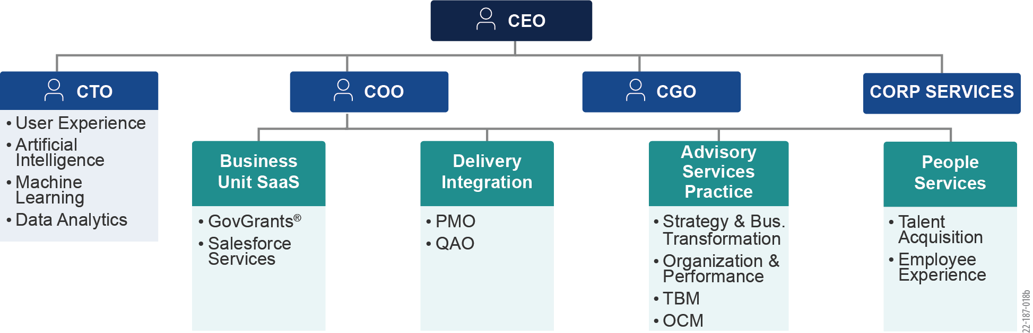

Figure 2: REI Systems’ Corporate Organization

All projects at REI are supported by the Project Management Office (PMO). The PMO is tasked with ensuring all projects are operating by the norms and standards established over the last 33 years designing, developing, and deploying mission-critical IT systems for government agencies. Monthly reporting for each project by the PMO drives risk mitigation and superior project execution at scale. Moreover, the proposed personnel/project team can easily reach back into the depth of Team REI’s grants management expertise to assist with any possible project surge needs that are discovered throughout project delivery or with specific technical guidance. The entire GovGrants organization is divided into three teams: Product, Implementation/Delivery, and Customer Success. Each team has its own lead and respective staff members to support the corresponding activities executed by each team. **Figure 3** below depicts Team REI’s organization chart specific to the GovGrants product.

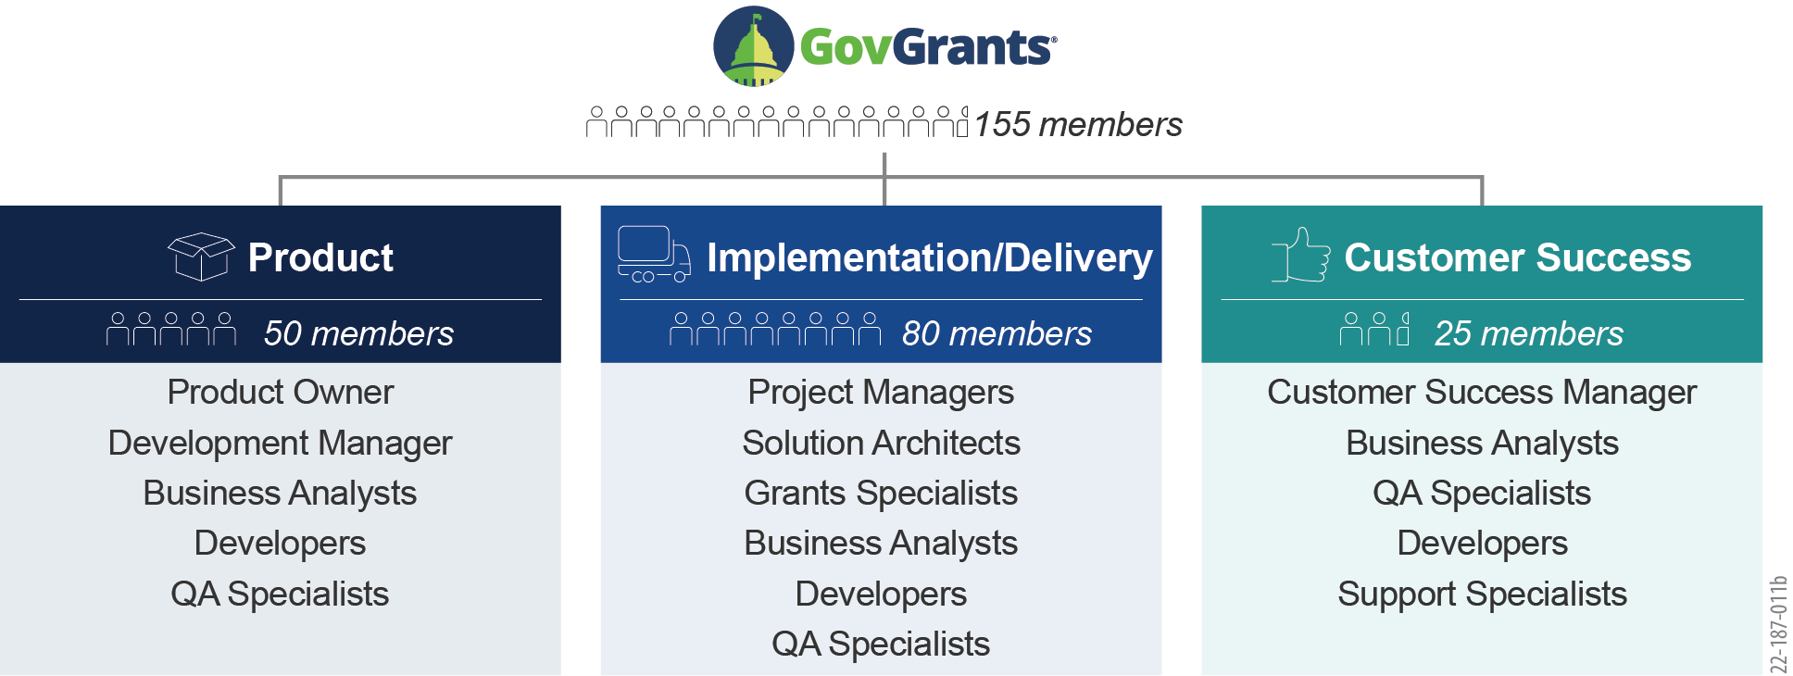

Figure 3: GovGrants Organization’s Three Teams: Product, Implementation/Delivery,  
and Customer Success

GovGrants’ successful implementations demonstrate a history of working together that assures our corporate and personal commitments to mission success. With each GovGrants project, REI assembles a team that provides the optimum expertise needed to ensure ongoing, successful delivery. By drawing additional staff as needed from a multidisciplinary pool of business and technical experts, we can provide the right resources at the right time to meet IAF requirements.

# Staffing Approach

Our people are at the forefront of our success in working with government institutions. As an organization with more than 700 staff members, REI is dedicated to the growth and development of our people. Indeed, REI is recognized for its culture that takes good care of its employees. As a **six-time winner** of ***The Washington Post’s Top Workplaces*** award, we pride ourselves on being a company where people build enriched and fulfilled careers.

Ability to Support IAF Objectives

Achieving IAF objectives means finding and keeping the right resources to ensure the highest productivity and collaboration throughout the contract. Team REI uses a combination of full-time and matrixed staffing approaches and proven recruiting processes that have been developed and fine-tuned over multiple similar IT programs. We provide individuals that best match the task skill requirements, offering each customer a best-value approach tailored to the solution itself. This flexible model ensures excellent customer service and satisfaction of IAF’s current and future goals by providing a team of dedicated staff and specialty staff when needed during various phases of the implementation. The staff is drawn from our pool of specialized IT professionals who understand the core grants management processes and business needs as well as directly relevant technology.

Our team proposed for the GMS project has supported numerous federal, state, and large foundation customers in their journey for grants management automation, including HRSA, DHS FEMA, NASA, LSC, NED, NFWF, State of Washington, State of South Carolina, State of Utah, and more. Collectively, the team will bring lessons learned from these experiences to support IAF's future ambitions of a more efficient and effective grants management process. The proposed team will also have reach back into grants SMEs within REI to support grants business process redesign and other deep-dive expertise, if and as needed.

Using a core team (PM, BA, DEV, QAS) for implementation provides the optimum team size necessary to execute the development work efficiently using REI’s Agile Scrum methodology while keeping development costs under control. Both the PM and the BA proposed for the project have extensive, strong experience implementing grants management systems across multiple REI customers and have an in-depth understanding of GovGrants and the grants domain. Similarly, we will staff the project with a Senior Developer with 5+ strong years of GovGrants and grants experience supporting GovGrants implementations for several state and large foundation customers in their journey for grants management automation. Team REI will staff the project with QAS with grants management and GovGrants experience. Therefore, the mix of core resources proposed for the project allows enough backup of SME and technical resources to continue project execution with little or no impact on the project cost and schedule.

Ability to Fill Positions

Team REI maintains an in-house recruiting staff of more than ten individuals to identify and attract qualified, diverse staff for IAF by reaching back to more than ten professional talent firms for additional surge support. We recruit by applying a rigorous interview process, panel interviews by technical and management staff, tests for competency and logic such as Brainbench, as well as tests for coding excellence, including HackerRank. We develop the identified staff by filling any gaps with internal training and other educational opportunities and certification.

We screen all candidates for creativity and mission orientation to ensure alignment with our purpose-focused culture. We use the following methods to establish a ready pipeline of candidates.

* **Proactive Recruiting:** Our forward-looking approach to recruiting staff involves market scans and interviews in anticipation of future resource needs. By engaging with prospective hires in advance, our team significantly reduces the time needed to onboard a candidate.
* **Internal Employee Mobility Program:** At REI, mobility means that employees have a clear path to grow in their careers by changing career paths or delivery projects. The mobility process exists to provide talented employees with a new avenue to pursue new intellectual challenges and broaden their skillsets and professional experiences. We will use this process to match an employee to a position on the IAF contract that lets them move in a direction that fits their career objectives and best serves IAF. On one of our contracts, FDA SIRCE / OCI / Admin / Imports / Laboratory (SCAIL) Support, around 15% of the program staffing, including senior leadership, was staffed through the mobility program.
* **Sponsoring and Hosting Innovative Events:** Team REI sponsors and hosts hackathons, happy hour hiring events, computer science challenges, and emerging tech expos to meet new talent.
* **Employee Referrals:** Team REI’s employee referral program provides cash rewards (from $500 to $8,000) when employees refer a new applicant who is hired and retained for at least three months.
* **University Partnerships:** REI sponsors an annual computer science challenge in conjunction with the University of Maryland and has conducted recent on-campus recruiting events at the University of Mary Washington, Virginia Tech, and Liberty University. In addition, REI also conducts partnership events and forums with Johns Hopkins University, Coppin State University, Norfolk State University, George Washington University, and Howard University.

Team REI, using the hiring methodology mentioned above, has successfully hired and onboarded more than 300 staff members over the last 12 months, out of which around 175 staff members have been hired since the start of this year.

Ability to Retain Personnel and Knowledge

Team REI’s corporate recruiting and retention processes are proven to attract and retain skilled experts through our opportunities for professional development, monetary incentives, benefits, and progressive employee support initiatives.Team REI utilizes a three-phased approach to develop employees, including our hands-on Leaders and T-shaped (cross-functional) delivery staff. We use a “promote from within” approach to motivate all our resources to continuously develop themselves and look toward the future. In Phase 1, staff focus on taking ownership of their role and their impact on the project/program. During Phase 2, we encourage our employees to become leaders by challenging them and expanding their soft and technical skill sets. Finally, in Phase 3, we encourage our more senior resources to coach, mentor, and train a successor. As part of our training, mentoring, and coaching of successors, our key personnel and other resources develop and maintain operational guides, Standard Operating Procedures (SOP), organizational charts, and other documentation that are stored in a repository (i.e., SharePoint), making these materials accessible to the team for training and onboarding purposes.

We have a skilled and professional workforce and boast a high retention rate of 90 percent on grants projects, better than industry averages, which translates to workforce stability. REI continuously invests in the professional development of our staff by instituting strong mentorship, training, and career progression programs, including the following.

* **Professional Development:** REI provides a full slate of in-house training that includes dedicated classroom sessions, brown bag sessions, and online courses for technical and soft skill development. We also provide up to $4,000 a year for each employee to invest in their professional development through external training, education, and certifications.
* **Recognition and Rewards:** REI believes that recognition and rewards are equally important in motivating good work. We recognize individual performance with on-the-spot awards and bonuses, recognition awards, annual performance bonuses, as well as team impact awards.
* **Long-Term Benefits:** REI’s Employee Stock Ownership Program is a key way for our employees to celebrate the success of our organization and helps to incentivize their continued hard work as an owner of our company. In 2018, an external benefits assessment firm rated our 401(k) program “best-in-class” for an organization of our size.

We require frequent touchpoints with our staff, including monthly one-on-one meetings, quarterly assessments, and an annual appraisal process, all of which ensure consistent and diligent touchpoints to evaluate progress and opportunities for growth, training, and expansion of skills. We identify areas of improvement and apply course corrections as soon as gaps are identified.

GovGrants Onboarding

Team REI onboards its new employees with classroom grants management training followed by product walkthroughs. This shows the new team member how the product maps to grant management processes. Following classroom training, they undergo the GovGrants product framework training. During the whole process, trainers administer quizzes to validate their understanding. In addition, for developers, we walk them through the technical delivery process as well as the product code structure. All of the training recordings are stored at a central location for easy future access.

Ability to Retain and Manage Subcontractors

The subcontractor proposed for the project, Stealth Solutions, has been a long-term partner with REI helping deliver GovGrants for seven customers for more than eight years. REI has a well-defined process for managing and onboarding subcontractors. Team REI’s PM works closely with Stealth Solutions and oversees its resources working on the implementation. Our PM escalates any Stealth resource concerns/issues to Stealth leadership for timely agreed-upon resolutions. If necessary, REI requests that Stealth provide replacement resources from its pool of resources who have GovGrants and grants domain experience. So far, REI has seen minimal turnover of Stealth’s technical and functional resources supporting multiple GovGrants implementations.

*The remainder of this page is intentionally blank.*

APPENDIX A Key Personnel Resumes

On the following pages, REI provides resumes for the following proposed personnel:

* Project Manager
* Technical Manager
* Business Analyst

In accordance with solicitation instructions, all names have been withheld and will be provided upon contract award.

A1 Project Manager

The proposed Project Manager (PM) has more than 17 years of experience in IT software application development, contributing to different stages of a project’s lifecycle, including business and system analysis, requirements gathering, system design, system testing, system maintenance, documentation, end-user support, and project delivery and management. Most of the experience (15+ years) is with working on grant management systems for several federal and state customers, such as the Health Resources and Services Administration (HRSA), Federal Emergency Management Agency (FEMA), National Aeronautics Space Agency (NASA), National Fish and Wildlife Foundation (NFWF), Puerto Rico Department of Health, and Washington State Office of Superintendent of Public Instruction (OSPI).

Over the last 11 years, this PM has developed core competencies in the areas of business analysis, hands-on requirements gathering, requirements management, solution concept development, project delivery, and management. He is an experienced Project Manager and Product Owner who has managed multiple parallel projects with an average team size of up to 15 members (avg. annual budget of $2 million) with a mix of Agile and Iterative Software Development Lifecycle (SDLC) methodologies.

TECHNICAL DOMAIN AND FUNCTIONAL EXPERTISE

|  |  |  |
| --- | --- | --- |
| * Grants Management (Federal and State Governments) | * Agile and Iterative Development | * Business Solution Development |
| * Requirements Gathering and Management | * Project Management and Product Ownership | * Technical Analysis and System Troubleshooting |
| * Section 508/Accessibility Compliance | * Agile Process Implementation | * End User Training |
| * Help System Development and User Documentation | * ISO 9001:2000 | * CMMI Level 3 |

EDUCATION

* M.S., Mechanical Engineering, University of Cincinnati
* B.E., Mechanical Engineering, Dayanand Sagar College of Engineering (Bangalore University)

CERTIFICATIONS AND TECHNOLOGY-SPECIFIC TRAINING

* PMI PMP, December 2013
* Introduction to Grants & Cooperative Agreements – Certification (Management Concepts), January 2020
* Monitoring Grants and Cooperative Agreements – Certification (Management Concepts), February 2020
* SOAR Leadership Training from Chalmers Brothers, 2015
* Dale Carnegie Training, Leadership Training for Managers, 2007
* SEI, Introduction to CMMI, Staged Representation, v1.1, 2005
* SEI, CMMI v1.2 Upgrade Training

PROJECT EXPERIENCE

REI Systems, Inc. 10/03 – Present

REI Systems (GovGrants) 6/17 – Present

Program Manager/Product Owner

Responsibilities

* Currently accountable for the implementation of GovGrants at Washington OSPI and the South Carolina Department of Education.
* Managed the implementation of GovGrants at the NFWF and Puerto Rico Department of Health in 2020.
* Prepares project plans and schedules, monitors team progress and project budget, reports status to the customer and REI senior management, escalates and manages project risks, prioritizes scope, develops business solutions, prepares key project documentation, and supports system usage and adoption.
* Provides functional expertise to the GovGrants product team and other project teams involved in supporting GovGrants implementation for REI’s state and local government customers.
* Uses Agile/Scrum methodology for his projects and continues to demonstrate his ability to play the product owner role.
* Is actively involved in eliciting requirements, mapping GovGrants processes to client processes, reviewing and prioritizing user stories, and engaging with the Development Team to ensure that we meet and, at times, exceed the customer’s requirements and expectations.

REI Systems12/08 – 5/17

Senior Project Manager/Product Owner, HRSA Grants

Responsibilities

* Was accountable for coordinating and managing parallel projects with a total team size ranging from 7 to 18 (average 15) members and an annual project budget of approximately $2,000,000.
* Managed parallel projects for two products (Program Oversight Module (POM) and Enterprise Portal Services (EPS)), focusing on business analysis, requirements gathering, project delivery, and product management. The projects used Agile/Scrum approaches and required a significant production release at least once every 4-6 months.
* Prepared product roadmaps, project plans, and schedules; monitored team progress and project budget; reported status to the customer and REI Senior Management; escalated and managed project risks; prioritized scope; developed business solutions; reviewed key project documentation, and supported system usage and adoption.
* Worked with HRSA staff to gather requirements, develop solution concepts, and support management and delivery of multiple grants management capabilities, including Grants Application and Attachment Module (GAAM), a program-specific application data and application review module, Progressive Actions (post-award conditions monitoring), Off-Cycle Conditions (capability to issue grant conditions post-award), Site Visits (post-award grantee visits and monitoring), POM (a comprehensive tool for post-award monitoring), and BHCMIS 2.0 (a collection of features and enhancements that supports teamwork, collaboration, and workload management for grantors).

Results Achieved

* The POM product managed by the proposed PM allowed the Bureau of Primary Health Care staff within HRSA to significantly increase their efficiency (time savings) in monitoring portfolio grantees.
* The Site Visit and Off-Cycle Conditions (OCC) projects helped HRSA staff significantly improve efficiencies in their post-award monitoring.
* The GAAM project allowed BPHC within HRSA to collect program-specific information for more than 3,800 grant applications and to efficiently review the grants applications from a programmatic perspective.
* Further, the GAAM project provided tools to allow BPHC staff to efficiently review the grant applications from a program perspective.

*The remainder of this page is intentionally blank.*

A2 Technical Manager

The proposed Technical Manager (TM) is the Product Manager for the GovGrants product and has been involved in a technical/advisory capacity with all GovGrants projects. He has 14 years of extensive experience in hands-on Salesforce development and architecture (A total of 22 years of experience of IT experience). With many years of experience designing, developing, and leading international teams across the US, Europe, and Asia consisting of project managers, executives, and development teams, this manager has Spearheaded multiple full lifecycle projects, including Salesforce.com (Sales Cloud, Service Cloud, Platform), Eloqua, Marketo, Siebel CRM, OpenAir, and webMethods middleware. He has also established Agile Scrum and Kanban Pods.

TECHNICAL DOMAIN AND FUNCTIONAL EXPERTISE

|  |  |  |
| --- | --- | --- |
| * Salesforce.com | * Data Loader | * Apex |
| * Visualforce | * Workflow | * Approval Process |
| * Flow | * Oracle | * SQL Server |
| * Enterprise Information Management (EIM) | * Siebel * Workflow | * Enterprise Application Integration (EAI) |
| * Project Management | * PL/SQL | * Business Services |

EDUCATION

* Bachelor in Business Administration, University of Madras, India
* Master of Business Administration (MBA), Strayer University

CERTIFICATIONS AND TECHNOLOGY-SPECIFIC TRAINING

* Certified Platform Developer 1
* Salesforce Certified Platform App Builder
* Certified Salesforce.com Administrator
* Certified Experience Cloud Consultant
* Certified Tableau and Einstein Discovery Consultant
* Certified SaFe5 Product Manager
* PMP Certified

PROJECT EXPERIENCE

REI Systems, Inc. 12/17 – Present

Solutions Architect

Responsibilities

* Product Manager responsible for managing GovGrants Product, a leading enterprise grants management product built by REI Systems.
* Responsible for the product roadmap, backlog, sprints, and deliverables.
* Perform periodic security reviews to ensure GovGrants is part of AppExchange.
* Manage a large team for product development. This includes two separate teams of Framework and Product.
* Works with vendors and partners to enhance the product landscape.
* Participates in larger customer discussions to plan the product features and improvements.
* Conducts requirements gathering and design sessions, oversees development and QA, and provides support for releases every four to six weeks.
* Serves as liaison between all project teams and provides quick resolution for their issues.
* Created a certification exam for the GovGrants product consisting of multiple-choice questions and answers.
* Conducts demos to a broad audience of developers, testers, project managers, etc.

Microstrategy Inc.5/17 – 12/17

Solutions Architect

Responsibilities

* Introduced Agile concepts and established a two-week Sprints cycle.
* Worked with Salesforce Customer Success on Lightning Accelerator.
* Launched Lightning Experience (LEX) to Pilot users.
* Implemented Marketo automation tool and its integration with the Salesforce Customer Relationship Management (CRM) application.
* Designed and developed a custom application to replace an existing legacy application.
* Implemented new features using Apex, VisualForce, Process Builder, Workflow, Custom Objects, Approval Processes, etc.
* Reviewed Salesforce Configure, Price, Quote (CPQ)
* Implemented a process to comply with Sarbanes-Oxley(SOX) Compliance. Cleaned up Profiles, Permission Sets, Sharing Rules, etc.
* Supported post-go live support tickets and enhancements of the FinancialForce Professional Services Automation (PSA) application.
* Interacted with C-level staff on a weekly basis to provide project updates, demos, and long-term planning.
* Worked with fellow leaders to establish a regular cadence for new initiatives.
* Managed a team of developers and administrators.

Capital One Bank1/14 – 5/17

Master Software Engineer – Salesforce

Responsibilities

* Hands-on development of Salesforce, including declarative configuration and programmatic development.
* Built roadmap for migrating towards Lightning Experience.
* Involved with various aspects of the project, which included Custom Objects, Approval Processes, Workflows, Apex Classes, Triggers, Visualforce Pages, Validation Rules, Process Builder, Custom Settings, SSO setup, Platform Encryption, Lightning, etc.
* Led and successfully implemented multiple custom applications using Salesforce1 Platform for various projects.
* Implemented new processes for release management, sandbox deployments, new features implementation, etc.
* Integrated Salesforce with back-end legacy applications using SnapLogic and other tools.
* Worked closely with business partners, audit team, security group, and architecture to design solutions.
* Gathered requirements, designed and architected the application, managed workload with onshore and offshore resources, and showcased the application to the business.
* Engaged in vendor discussions for encryption of Salesforce data. Early adopters of Salesforce Platform Encryption and Monitoring (Shield).
* Hired, mentored, and managed team members, interns, and contractors.
* Managed an Agile Scrum Pod, including Sprint Planning, Backlog Grooming, Daily Stand-Ups, and tracking of the project using the VersionOne application.
* Served as Co-Chapter lead for Asian Network Mclean Chapter. Organized multiple events throughout Mclean.

Software AG USA Inc.5/06 – 1/14

Global Manager / Salesforce Architect

Responsibilities

* Reported to CIO and managed yearly budgets, performance, resource allocation, and planning.
* Provided roadmap for various applications – Salesforce, OpenAir, webMethods, internal integrations.
* Built Integration of Salesforce using webMethods, Informatica, and other tools.
* Led and successfully merged two large Salesforce.com instances comprising 1,500+ users.
* Successfully managed a global migration of Siebel Sales (1,000 users) to Salesforce.com.
* Provided global Salesforce.com enhancements and support for 1,350+ users.
* Created a spin-off instance of Salesforce.com for the federal unit.
* Integrated Eloqua and Marketo marketing tools and implemented customized Lead scoring.
* Implemented Dun and Bradstreet for data quality with Astadia package
* Created various process improvement efforts for Account creation, product lists, naming terminology, enhancements, and support assignments.
* Worked in all areas of Salesforce.com — Configuration, Standard Objects, Custom Objects, Fields, Lookup Filters, Validation Rules, Page Layouts, Buttons and Links, Record Types, Web-To-Lead, Sales Processes, Assignment Rules, Home Page Components, Forecasts, Console, Custom Report Types, Tabs, Packages, etc.
* Iteratively improved functionality through the development of Apex, Visualforce pages, and objects.
* Implemented Salesforce.com Customer Portal, Sites, RADAR, Solution Selling, ReferenceStor, and other AppExchange packages.
* Developed web services using Salesforce.com Web services API to provide data for third-party clients and integrated Salesforce.com with SAP using webMethods middleware.
* Extensively used Data Loader for data loading and used CRM Fusion Demand Tools for data cleansing and data de-duplication.
* Implemented Salesforce CRM Content and customized Contracts module.

*The remainder of this page is intentionally blank.*

A3 Business Analyst

The proposed Business Analyst (BA) is an experienced analyst trained in public policy with demonstrated expertise in evaluation, grant writing, and grant management. The proposed BA has served as the Functional Lead on three states’ Department of Education customers. Her professional emphases include business processes and outcomes analyses. Her personal interests tend toward social impact, well-being measures, and cultural preservation.

TECHNICAL DOMAIN AND FUNCTIONAL EXPERTISE

|  |  |  |
| --- | --- | --- |
| * Business Systems Analytics | * Program and Policy Evaluation | * Data Analytics, Interpretation, and Presentation |
| * Strategic Planning and Budgeting | * Grant Management |  |

EDUCATION

* Master of Public Policy, University of Utah
* Graduate Certificate in Demography, University of Utah
* Bachelor of Science in Sociology, University of Utah

PROJECT EXPERIENCE

REI Systems, Inc. – Sterling, VA 1/18–Present

Functional Lead

Responsibilities

* Acts as the functional lead for GovGrants implementation across three state-level Department of Education projects.
* Drives requirements discovery, serves as the direct liaison between the client and the development team, and provides all necessary training materials and documentation.
* Participates in the analysis and design of solutions.
* Acts as a SME for the business domain, transferring knowledge to the development team.
* Assists in functional testing and User Acceptance Testing (UAT).
* Serves as primary liaison between client and project teams.
* Completed comprehensive functional requirements documentation for the GovGrants product.
* Supports trainings for internal staff as well as external users.

Oahu & Big Island12/15 – Present

Freelance Grant Writer and Evaluator

Responsibilities

* Grant writing, planning, and evaluation. Clients include non-profits, colleges, and charter schools.
* Awarded Grants:
* FY 2017 U.S. ED National Professional Development Program, Kanu o ka ‘Āina New Century Learning ‘Ohana, $2,250,000, Co-Authored
* FY 2016 U.S. ED Educational Opportunity Centers for the University of Hawai’i’s Leeward Community College. $1,180,000, Co-Authored
* Evaluation Projects:
* ‘Aha Pūnana Leo, U.S. ED Native Hawaiian Education Program grant evaluation
* University of Hawai’i – Leeward Community College, NSF TCUP grant evaluation
* University of Hawai’i – Leeward Community College, Title III Part A and Part F grants evaluation

University of Hawai’i, Leeward Community College10/14 – 1/16

Grants and Contracts Coordinator

Responsibilities

* Managed pre-award and post-award aspects of all federal, state, and foundation grants.
* Fulfilled programmatic and budget reporting requirements to granting agencies (Department of Labor (DOL), National Science Foundation (NSF), Department of Education (ED), and state-level agencies).
* Streamlined grant management processes and worked successfully with the University’s Office of Research Services, faculty, administration, students, external evaluators, and program officers.
* Managed pass-through funding to education centers, sub-campuses, and consortium partners.

*The remainder of this page is intentionally blank.*